Curriculum vitae
Persoonsgegevens:
Naam | : | Maikel Boezer
Voorletters | : | M.M.J
Geb. datum | : | 4 November 2003
Geslacht | : | M
Gehuwd | : | Nee
Adres | : | straat
Postcode & woonplaats | : | plaats
E-mailadres | : | email
Telefoonnummer  Nationaliteit  Rijbewijs | :  :  : | telefoon  Nederlands  B
Opleidingen:
Periode | Opleiding | Diploma
2025 – 2026 | Applied data science and artificial intelligence (HBO) | Ja
2022 – 2026 | Minor CyberStars: cybersecurity. | Certificaat
2020 – 2022  2020 – 2020  2020 – 2020 | Natuur en techniek (Havo)  Python beginner course Radboud Nijmegen  Kennismaking robotica hogeschool Utrecht | Ja  Plus document  Plus document
2016 – 2020 | Natuur en techniek (Mavo) | Ja
Nadere omschrijving van de opleiding(en):
Opleiding | : | Breda University of Applied Science (BUas)
Periode | : | 2022-2026
Diploma / certificaat | : | Diploma gehaald
Opleiding | : | Willem van Oranje college waalwijk (Havo)
Periode | : | 2020-2022
Diploma / certificaat | : | Diploma gehaald
Opleiding | : | Willem van Oranje college waalwijk (Mavo)
Periode | : | 2016-2020
Diploma / certificaat | : | Ja, cum-laude geslaagd
Werkervaring:
Periode  2026 – now  2026 – 2026  2025 – 2025  2024 – 2025  2023 – 2024  2023 – 2024  2023 – 2024  2023 – 2024  2022 – 2023 | Functie  Parttime junior data-engineer  Data engineer (afstudeeropdracht)  Data engineer & analytics translator  Data engineer (opdracht tijdens studie)  Data engineer (opdracht tijdens studie)  Data scientist (opdracht tijdens studie)  Data engineer/ Data scientist (opdracht tijdens studie)  Reseurser (opdracht tijdens studie)  Data engineer (opdracht tijdens studie) |  | Bedrijf  PlaySmart/Buas  Breda Guardians/ BUas  Stedin  Breda Guardians/ BUas  NPEC Utrecht/ BUas  Banijay benelux  NPEC Utrecht  BUas  gemeente Breda
2022 – 2023 | Data scientist (opdracht tijdens studie) |  | Banijay benelux
2019 – 2019 | Snuffel stage IT dienst verlening |  | ReallyIT
Taalvaardigheden:
Talen | Schriftelijk | Mondeling
Nederlands | goed | goed
Engels | goed | goed

De opleiding is engelstalig vandaar dat de uitleg over mijn skills en projecten in het engels is.
Skills and software skills:
- I have 4 years of experience with Python in these years I have made
  - Machine learning models
  - deep learning models
  - neural networks
  - computer vision(cv) models
  - Natural language processing (NLP) models
- I know how to work with Docker and prepare them to put on a server.
- I have worked with PowerBI to create dashboards for clients.
- I have automated a pipeline from data downloading to data visualization on a dashboard.
- I have set up branching strategies for a research project
My projects:
Graduation project:
Formalising deployment for the Breda Guardians Esports Analytics Toolkit, my graduation thesis project at The Hive, Breda University of Applied Sciences (BUas). The Play-Smart toolkit, an earlier prototype built by students, captured player performance data through eye tracking, facial emotion recognition, and keyboard/mouse input, feeding into a dashboard for esports coaching. The problem this project addressed was that deployment of the toolkit was still entirely manual: files were carried between machines by USB, paths were hard-coded, and the environment had to be reconstructed by hand on every new PC, which had become slow, fragile, and increasingly unworkable as more contributors and institutions (Tilburg University and the University of Twente) joined the project.
Because of this, the project came down to migrating the toolkit from that manual, USB-based process to a consolidated, version-controlled workflow built around GitHub, and evaluating whether that migration actually improved things, both in deployment speed and in the experience of the people doing the deployments.
I started by designing a branching strategy that could handle two problems at once: letting partner institutions work independently while BUas kept control over what got merged back, and giving student contributors enough structure to avoid mistakes without killing their ability to experiment. I solved this with a hybrid approach, a forking model between institutions combined with a Git-Flow-style main branch and GitHub-Flow-style feature branches within each institutional fork. I also built an automated deployment pipeline using GitHub Actions that detects which service changed (backend, frontend, pipeline, or inference container) and rebuilds and redeploys only that one, reducing both manual effort and the chance of human error.
To evaluate whether this new workflow was actually better, not just faster on paper, I ran a within-subjects usability study with four experienced project contributors, each of whom deployed the toolkit using both the old manual method and the new GitHub-based method, while I measured deployment time and collected their experience through a questionnaire built on the Technology Acceptance Model and the DORA and SPACE frameworks.
The results were consistent across all four participants: the GitHub-based method was faster for everyone, taking roughly 8 to 12 minutes compared to 22 to 33 minutes manually, with most of the manual time lost to USB transfer problems rather than the actual toolkit setup. It was also rated easier to use, less mentally demanding, more reliable, and more likely to be reused by every single participant. The automated pipeline itself also behaved as intended in production, correctly rebuilding and redeploying only the changed containers on real merges.
In conclusion, the study supported adopting the new version-controlled workflow as the standard way of deploying the toolkit going forward, and I documented the remaining limitations (small sample size, only tested with experienced users, some inconsistency in dependency distribution) as directions for future work.

Dashboard pipeline:
Making a Power BI dashboard for Stedin, an electricity and gas company in the Netherlands, to monitor the quality of the green gas fed into their network from 12 locations across the country. This project was for Stedin's green gas department, who previously only received quality reports every 6 months from a third party and had no easy way to check the gas quality themselves without manually downloading and processing data per location, a process that took 15 to 30 minutes each time. Because of this, the project came down to building a dashboard that tracks all the relevant gas values, Oxygen, Carbon dioxide, water dew point, pressure, Hydrogen sulphide, and Wobbe index, and automating the process of getting that data onto it.
We started with data collection, which comes from a third-party company called TeleControlNet (TCN) that compiles data from all the feeder locations. Since TCN's API didn't allow downloading data in the format needed, I used robotic process automation (RPA) in Python to mimic the actions of a user downloading the data manually from the website.
After downloading, the data needed to be cleaned and filtered before it could be used, since the amount and quality of data varied a lot between locations. During this process I found a few anomalies: one location measured pressure differently than the others (not a real problem, just an inconsistency in units), and three other locations had a large percentage of missing data in one column because a provider had set up recording differently than the rest of the system, which meant that column had to be dropped for those locations to keep the rest of the data usable.
The last part of the project was to automate the whole pipeline and finish the dashboard. I built an executable application that runs the RPA download, moves and renames the data, cleans and filters it, and saves it to an export folder connected to a SharePoint location that feeds directly into the Power BI dashboard. This meant my supervisors could refresh the dashboard themselves without needing to touch the underlying code. I also built a custom Wobbe index visual in Power BI using a Python visual, translating an existing Excel-based calculation into Python logic, since there was no standard way to replicate it in Power BI.

AI coach:
The last project I worked on was about making an AI coach for an E-sports organisation named Breda Guardians which is based in the HIVE at Brade University of applied sciences (BUas). This project is a multi-year project for students of the applied data science and AI (ADS&AI) course, I was part of the first group to work on this project so we had to build everything from the ground up. Because of this, we had to acknowledge that making an AI was not feasible with the time we had to work on this project so we decided to lay the groundwork for the next groups and create a dashboard to show the progress.
We started with data collection, we collected: keyboard and mouse inputs, gaze data, facial expression data, and video data. The input data is collected through a Python script, gaze data with a Tobii eye tracker, facial expressions or emotions with the use of a webcam and a computer vision algorithm provided by open-face and the video is recorded with OBS.
After setting up the data collection we started building a data storage system, we decided on using SFTP for our bulk storage and PSQL for organizing the data. To make sure that everything would work on a server and to make it automatic we made a docker container that is running both the SFTP server and the PSQL server.
The last part of the project is to automate it and make a dashboard. For the automation part, we made it so that when data collection stops it gets uploaded to the SFTP server and that the numeric data then gets uploaded to the PSQL server. Then if the dashboard wants to display some of the data it can find it in the PSQL server.
Below you can see a sort demo of the project.
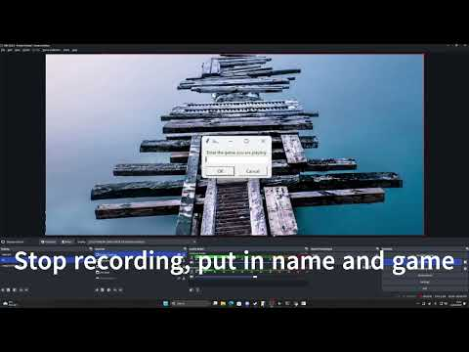

Computer Vision NPEC:
For this project, I needed to make a computer vision algorithm that could Isolate the roots of plants, find the coordinates of all the root ends, calculate the length of the main root and then move a robot to those coordinates and water the plants at these points.
The algorithm I used for this is a convolutional neural network or CNN called U-Net. A U-Net model specialises in image segmentation which means that the model works with only segments or parts of the image(1.) instead of trying to process the whole picture at once, one of the reasons to do this is to reduce the workload for so the model is able to run and run faster than other models. The model's output(3.) was not bad either with a little bit of cleaning the picture, and I had something I could work with.
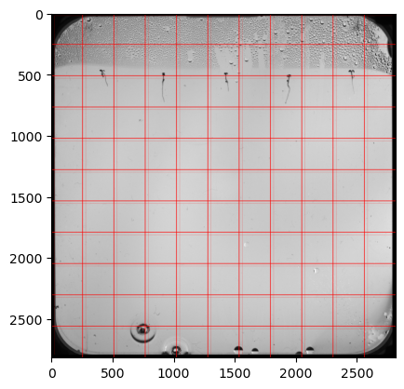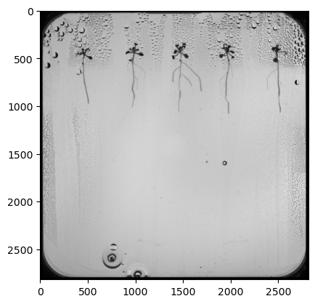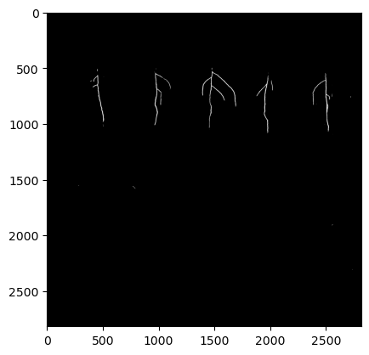
1. How pictures get segmented.
2. Input picture for the model.
3. Output of the model.
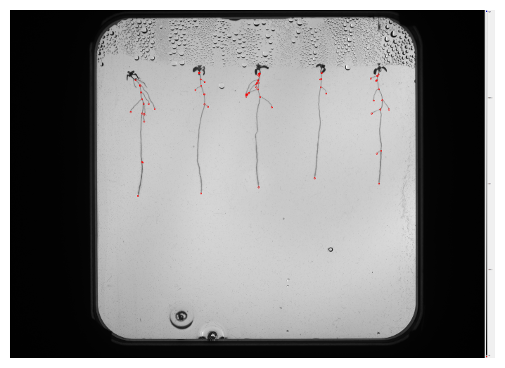
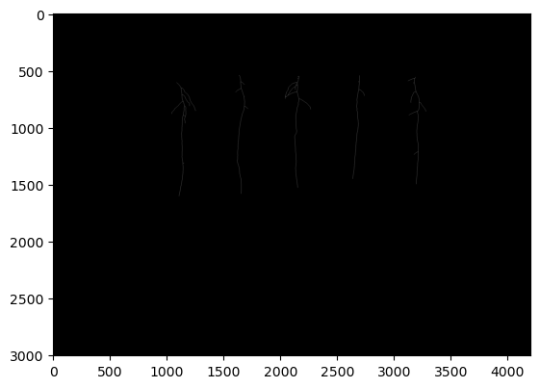
With the roots isolated I was able to skeletonize(4.) the image which turns everything in the image into a line or a skeleton of the image, with this I could find all the coordinates of the beginning and end of every root(5.). after this I isolated the roots(6.) and got the length from the main root(7.).
5. Visualization of the coordinates
4. Skeletonized version of the images

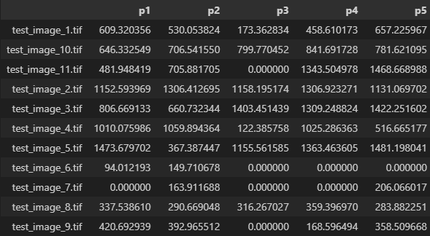
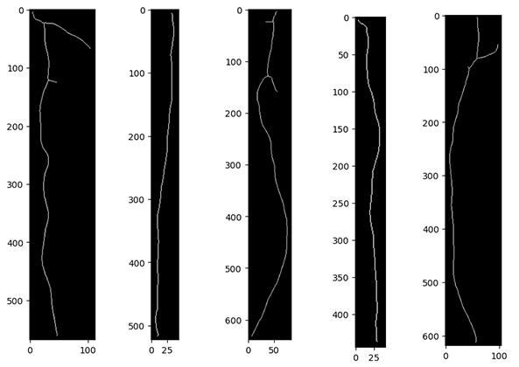
7. Root lengths
6. Isolated roots

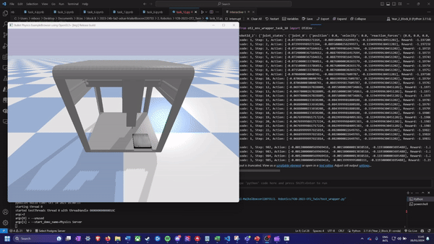
For the robotics part of this project, I did not get as far as I would have liked. I got a simulation of the robot that we used for testing moving(8.) but I did not have time to make things automated.
8. Simulation of robot moving

